**Weather Data Collection at SCBI-Front Royal-Posey Hollow**

PI: Kristina Teixeira

Prepared by: Erika Gonzalez-Akre

October 2017, updated January 2019 **Method:** LoggerNet software, chunky computer tablet

BEFORE you go to the field make sure the chunky laptop battery is 100% charge

In the field:

1. Open upper metal box on tower.
2. Connect laptop to datalogger using the white USB cable. Connect to portal RS-232.
3. Open the LoggerNet program on the desktop
4. Click “Status” on LoggerNet toolbar
5. Select “Weather-CR1000” under “Network Map”
6. Click “Collect Now”. You will be able to monitor the collection time by scrolling to the right. Wait until finish (variable time). Close program.
7. 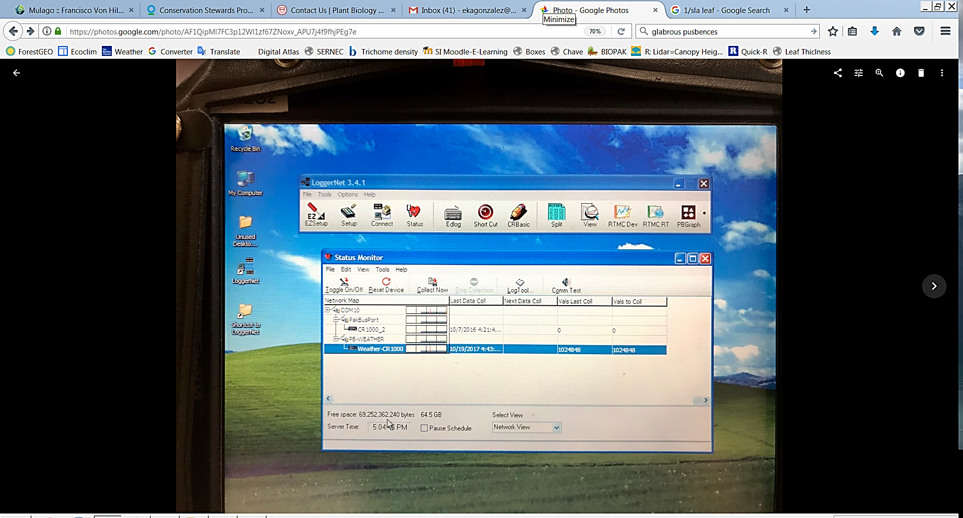On the desktop, open the folder “Data from LoggerNet”. Verify that the data was properly downloaded by opening the file and quickly scanning for record accuracy. Make sure that you downloaded records up to the date/time you are collecting the data.

In the lab:

1. Save raw .txt file to T:\SIGEO\Met tower\Meteo DATA\TXT_Files\ and change file name to include date of collection (e.g. Weather-CR1000_Metdata_5min_08232018).
2. Change the file extension to .txt.
3. Paste new data in the .txt file ‘SCB_Metdata_5min_YEAR’.
   1. Select data quickly using Ctrl+Shift+End.
4. Also update new data in the .csv file: SCB_Metdata_5min_YEAR.
   1. In Excel, select the first empty cell in column A. Go to “Data”, then “Get External Data” and “From text.”
   2. Select the .txt file you just updated in Step 3. Start import at the same row number as the first empty row in the csv file (where you selected). This ensures it only imports what you need starting at that empty cell.

We use the SI network as backup repository BUT next step is more important!

1. Ask Krista to send you an invitation to access the ‘Climate Repository’ in GitHub.
2. Steps on Github:
   1. Navigate to your local GitHub repositories. Move the updated .csv to

- forestgeo\Climate\Met_Station_Data\SCBI\ForestGEO_met_station-SCBI

* 1. Open GitHub desktop. You will see the modified file in your history
  2. Make a comment in Github (i.e. in Summary: “Updated records for 2018”, in Description: add any relevant comment or none)
  3. Commit to master.
  4. Push!